**Exercise 2: E-commerce Platform Search Function**

**What is Big O Notation?**

* Big O notation is used to describe the efficiency of an algorithm.
* It tells how the time or space used by an algorithm increases as the input size increases.
* It helps compare algorithms without depending on hardware or specific input values.
* It mainly focuses on how fast or slow an algorithm performs in the worst-case scenario.

**Common Notations:**

* **O(1)** – The algorithm takes the same amount of time no matter the input size.
* **O(n)** – The time grows in proportion to the input size.
* **O(log n)** – The time grows slowly even as the input size increases.
* **O(n log n)** – The time grows faster than linear but slower than quadratic.
* **O(n²)** – The time grows quickly as the input size increases, especially with nested operations.

**Best, Average, and Worst Cases in Search:**

* **Best Case** – The condition where the algorithm finishes the fastest.
* **Average Case** – The expected performance over a range of typical inputs.
* **Worst Case** – The condition where the algorithm takes the longest time to complete.
* In linear search: Best case is very quick and average and worst cases take longer as input size increases.
* In binary search: All cases perform efficiently with increasing input size, especially if the data is sorted.

**Output:**

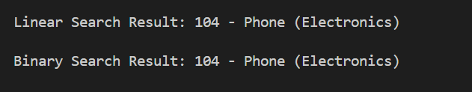

**Time Complexity Comparison**

* Linear search takes more time as the number of products increases.
* Binary search takes much less time because it reduces the search space quickly.
* Both use a small and fixed amount of extra memory.

**Which is Better for E-commerce Search?**

* Binary search is better for e-commerce platforms with large and sorted product lists because it is faster.
* Binary search is more efficient when the same search happens many times.